1. **Usability analysis & design**
2. Preliminary user interface design

Interface for the FDIR system has to be accurate, efficient and exhaustive. As a professional software, FDIR doesn’t need to be particularly easy to learn or user friendly, that is why our design is more focused on interface performance and on displaying the more information possible while keeping it logic and accessible.

FDIR system has to display continuous information about monitored values, systems state, interventions (by both human and computer), errors and warnings. That is why we don’t want to use tabs or any item that is hiding information as possible. We are using 3 main windows, supposed to be displayed on three different screens. We can focus on a specific part by using tree architecture containing a list of every systems, sub systems, and devices. Selecting a part affects the state of every screen, it is updating the allowed actions, it filters information on the log screen, and it is updating the spacecraft scheme in order to provide geo localization. User is also allowed to select the entire spacecraft and so every information about it will be displayed.

Another feature not described in the following prototypes is the case of a critical issue happening, FDIR will so have to provide an alert (like a pop-up system) so that the crew will be directly informed.

**Screen 1 : Systems displaying**

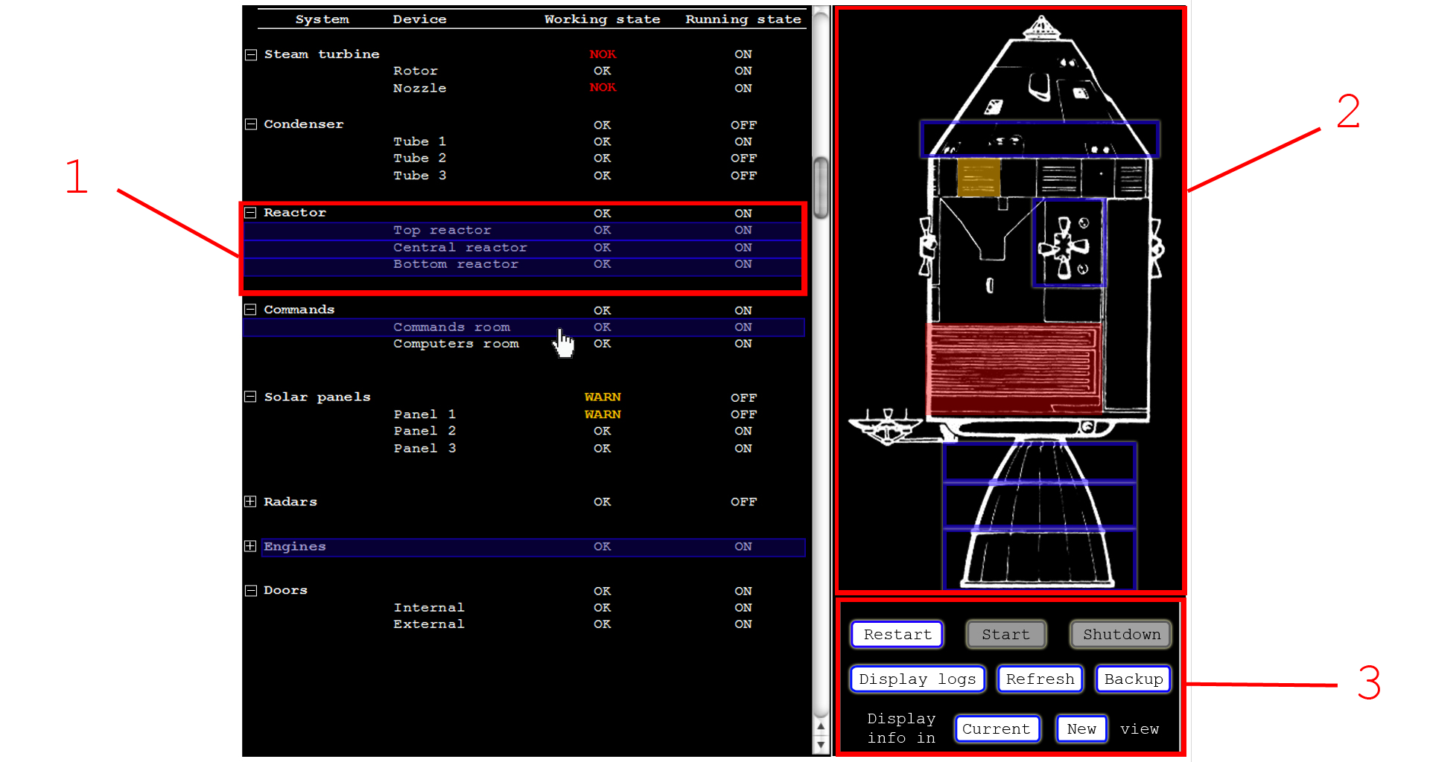

*fig1. Systems displaying window prototype*

1: In this tree panel we display every system, divided into several devices. Working states and running states will always be displayed in this tree. The user can make a multi-selection between several systems and devices, affecting the other two panels.

2: This panel gives a geographical localization of the selected parts to the user. This is useful in the case of a need of a fast human intervention on some part of the spacecraft.

3: This action panel displays every allowed action considering the selected parts. User is so able to start, restart, or shutdown a part or several parts of the system at anytime. He can also ask for a manual and direct refresh of the states, he can operate a change on the current used backups (a pop-up window will so appears to permit him to select which backups are currently working on the selected parts), he can make a filter on the log screen by considering only components selected on this view, and he can display monitored values corresponding to these components on the appropriate screen (on the current tab or opening a new one).

**Screen 2 : Monitored information**

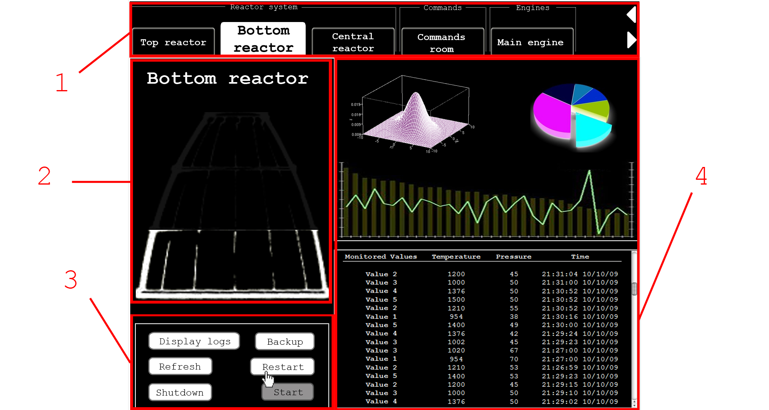

*fig2. Monitored information windows*

1: This tab system allows the user to manage this view by making groups of monitored systems/devices. We add new tab or new systems/devices to the current tab thanks to the system-displaying window, and we can remove tabs or groups of tabs on this window (not represented on the prototype).

2: This view offers a more accurate geographical view on the selected part, while the general view is always kept on the other window.

3: This action panel is basically the same that what was presented in the previously screen. The difference is that here we are considering a single part of the global system, no multi-selection are allowed.

4: Every monitored value is displayed here. We can sort them by period, increasing values etc… FDIR is also automatically generating stats, charts, and miscellaneous information, based on the monitored values.

**Screen 3 : Logs**

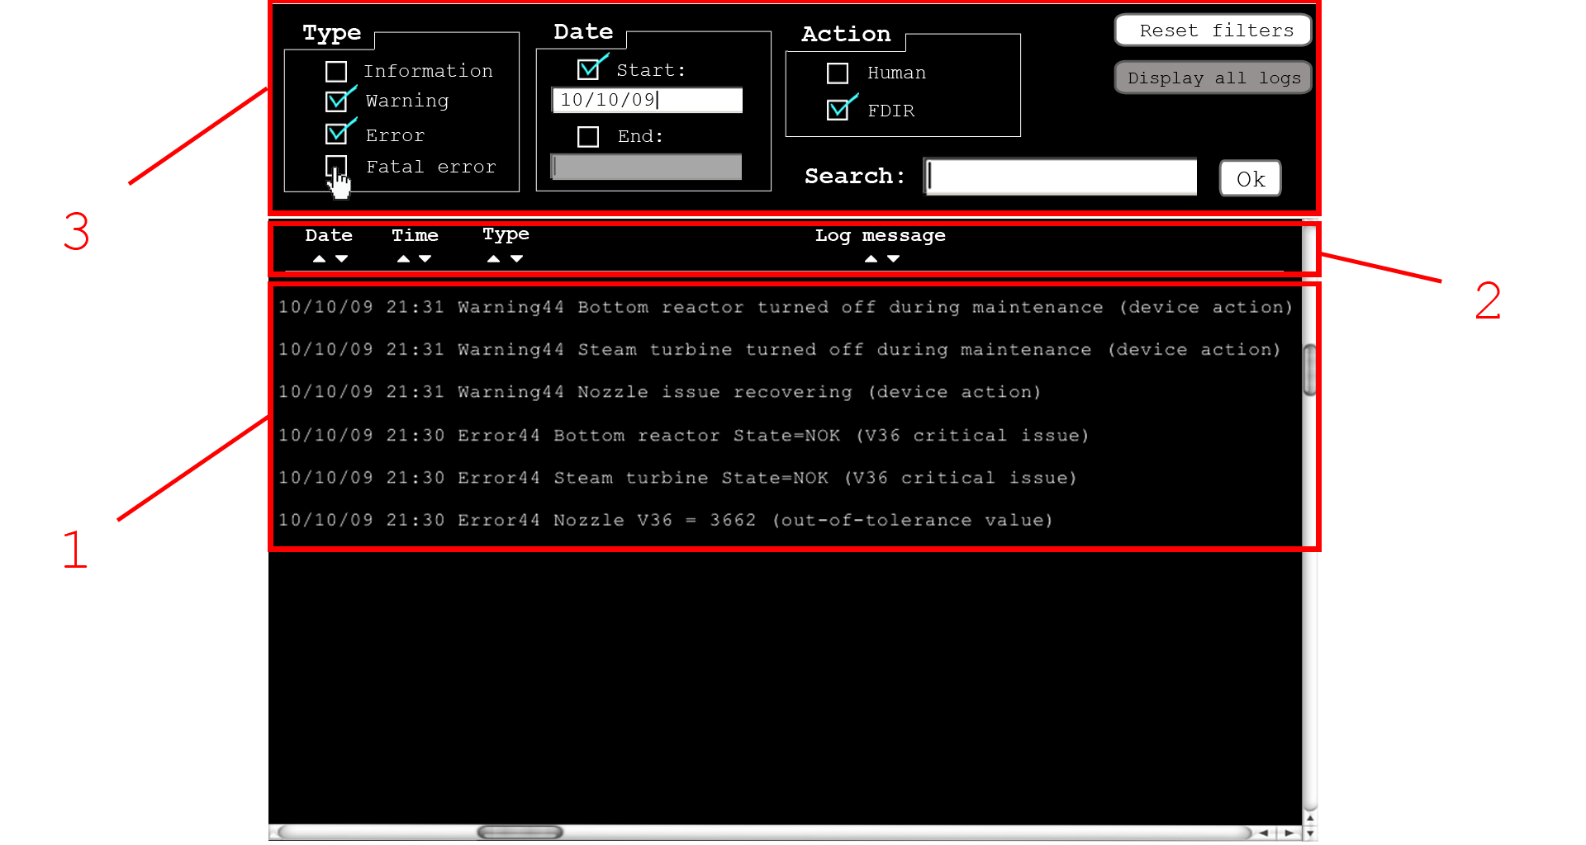

*fig3. Logs window*

1: In this panel we display every log information produced by FDIR, by specifying date, time, id of message, concerned component, monitored value or action, and type of issue or type of action. If we don’t apply any filter on its, that mean every information is accessible on this tab. We wanted to use a log system for this purpose, because this kind of tool is powerful and adapted to professional applications.

2: With this interface, user can sort displayed lines by date, time, type of information, and by name of message.

3: User is able to do filter operations in margin of the systems/devices filter operated on the system displaying window. He can choose between information type to display (information, warning, error, fatal error), and if displayed information is concerned by FDIR automatical intervention or human intervention. He can also make a filter by specifying dates of “start” and “end”. The button ‘Display all logs’ cancel the effect of systems/devices filters, and the button ‘Reset filters’ cancel the effect of other filters. A search allow user to perform a research through the log, for example if he types the string “panel solar”, only lines containing this string will appears on the first panel.

**Screen 4 : Backups management pop-up**

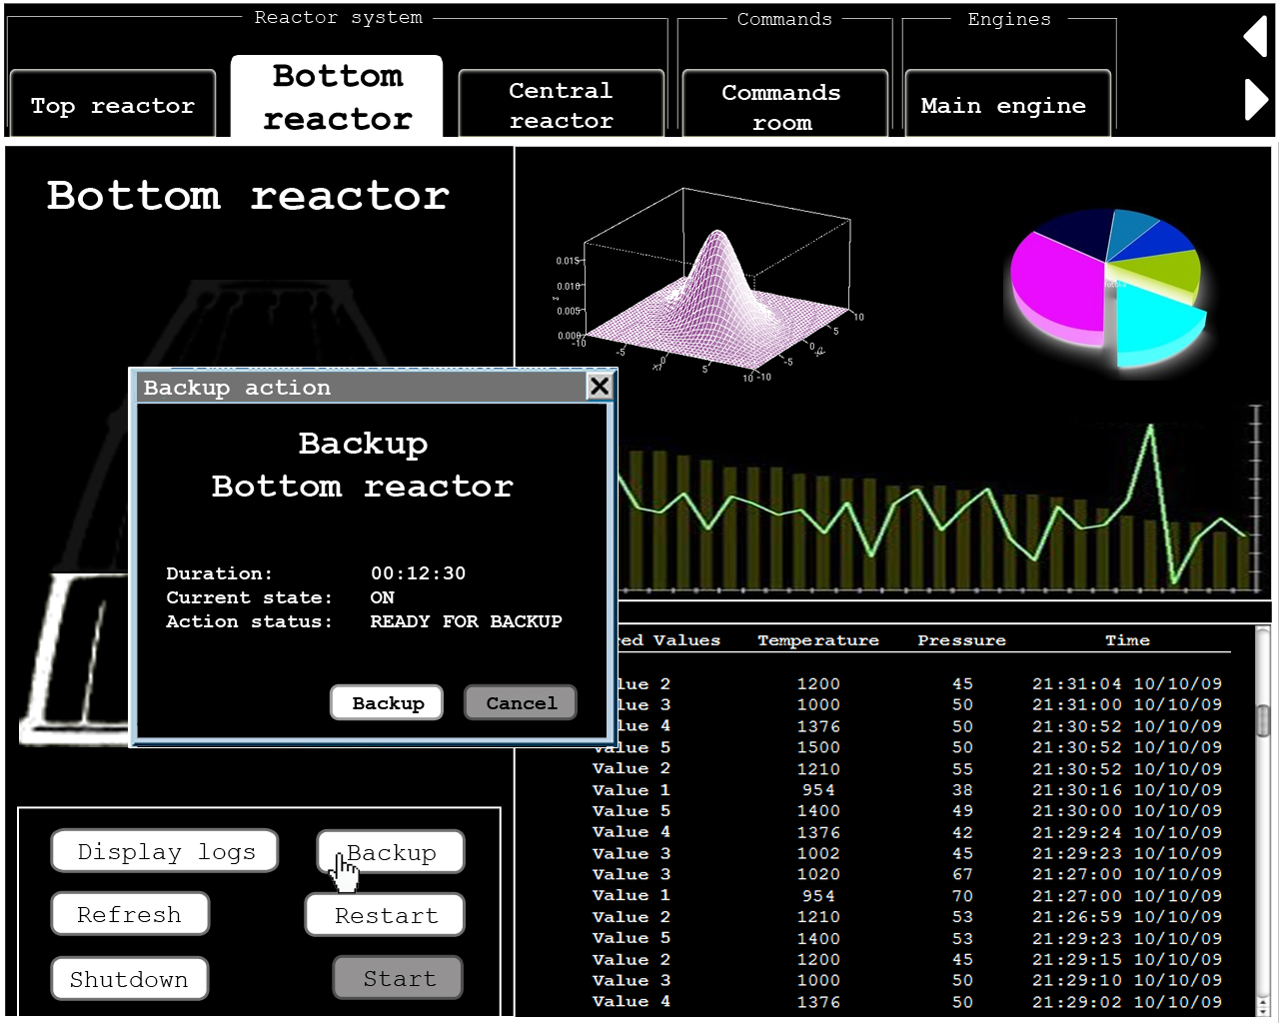

*fig4. Backup management pop-up before backup*

When the action “Backup” is selected, a window appears, allowing user to select a spare system. This pop-up then appears, informing the user of the expected duration of the operation, and allowing him to cancel the operation if this one is too long or for some other reason.

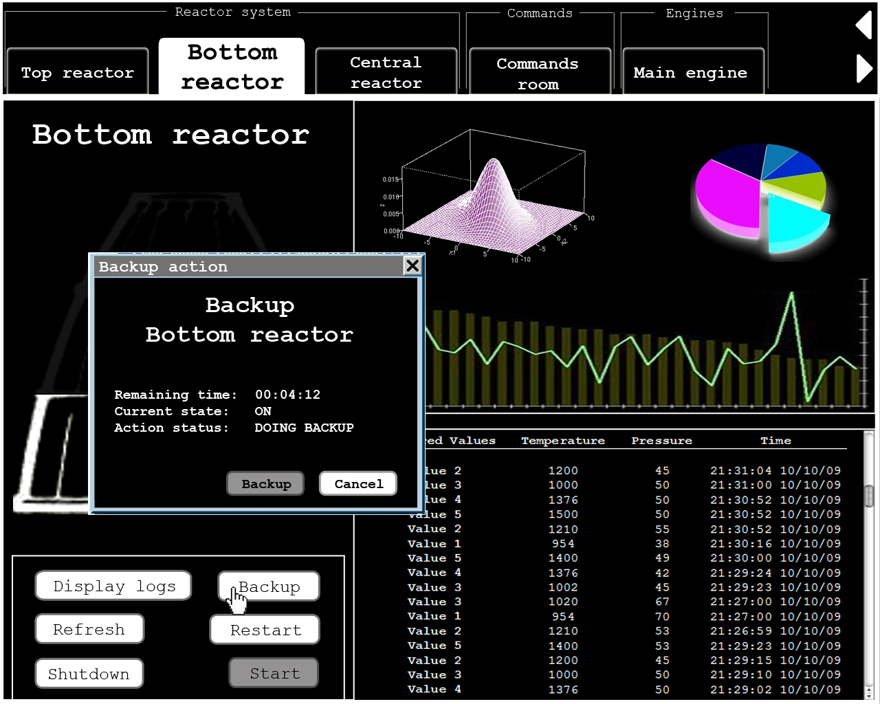

*fig5. Backup management pop-up during backup*

During the backup operation, this pop-up is still displayed, informing user of the remaining the action’s achievement. User is allowed to cancel the operation for some reason, and then the system recover automatically the original configuration.